BENEFITS OF CLOUD

1. AGILITY :- increase speed and agility
2. PAY-AS-YOU-GO PRICING :- benefits from massive economies of scale
3. GLOBAL REACH :- go global in minutes
4. SECURITY
5. HIGH AVAILABLITY
6. RELIABLITY :- Stop sapending money on running and maintaining data centers
7. Scalablity :- Benefits from massive economies of scales
8. Elasticity

AWS GLOBAL INFRASTRUCTURE

Globally Distributed Hardware and datacenters that are physically networked together to act as a one large resource for the end user.

25 Regions

81 Availablity Zones

Regions :- Geographically distinct locations consisting of one or more Availablity Zones . Every region is physically isolated from and independent of every other region in terms of location, power and water supply. Eg:- us-east1, us-west1

Q) WHAT FACTORS TO THINK IN MIND BEFORE CHOOSING A REGION ?

* Does this Region meet the Regulatory Compliance
* Cost of services in that region as it may vary
* Do the services are available in that region (as some services are not available in every-region)
* The Distance or latency to meet my end-users

AVAILABLITY ZONES

An Availablity Zones is a physical locations made up of one or more datacenters

A Region generally contains 3 AZ’s

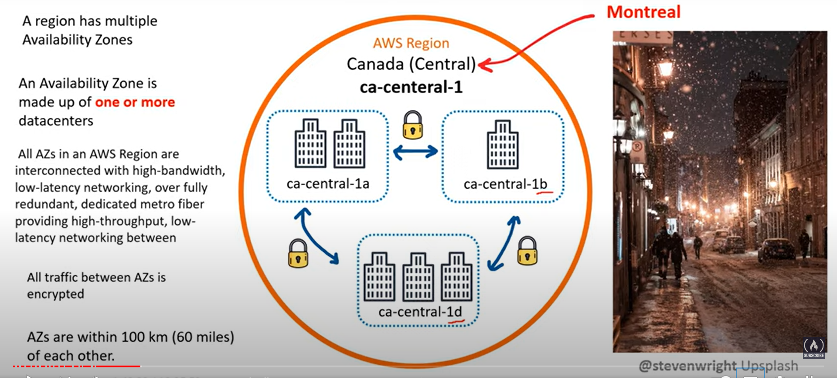

Fault tolerance :- A fault domain is a section of network that is vulnerable to damage if a critical device or system fails. The purpose of a fault domain is that if a failure occurs it will not cascade outside that domain ,limiting the damage possible

AWS GLOBAL NETWORK

AWS Global Network represent the interconnection between AWS Global infrastructure. Commonly referred to as the “THE BACKBONE OF AWS”.

Points of Presence(Pop) :- Intermediate locations between an AWS Region and the end user, and this location could be a datacenter

PoP’s resources are: 1)Edge Locations

2) Regional Edge Caches

Edge Locations :- Edge Locations are datacenters that holds cached (copy) on the most popular files (eg. Web pages , images , videos ) so that the delivery of distance to the end users are reduce

Regional Edge Locations :- These are the datacenters that hold much larger caches of less-popular files to reduce a full round trip and also to reduce the cost of transfer fees

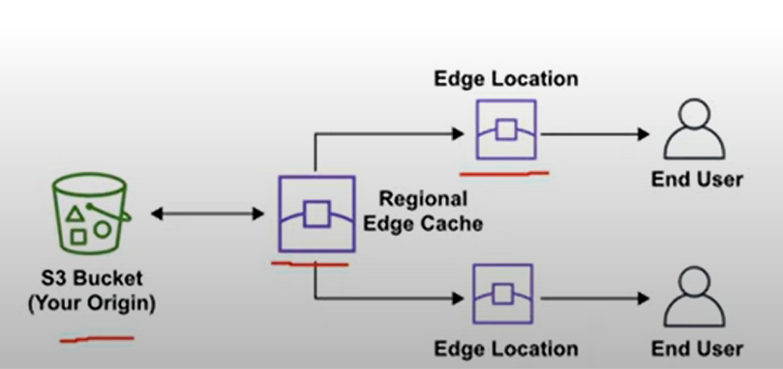

The following services use PoP for content delivery or expediated upload.

Amazon CloudFront :- CloudFront is Content Delivery Network (CDN) service that route request to nearest Edge locations cache , Allows us to choose an origin (web-server or storage) that will be source of cached

Amazon S3 Transfer Acceleration :- It allows us to generate a special url that can be used by the end users to upload files to a nearby Edge locations .Once a files is uploaded to an Edge locations it can move much faster within the AWS network to reach S3

Amazon Global Accelerator :- It can find the optimal path from the end user to your web-servers. Global Accelerator are deployed within the edge locations so you send user traffic to an Edge location instead of directly to your web-application

AWS DIRECT CONNECT

AWS Direct Connect is a private/dedicated connection between your datacentre , office , co-locations and AWS.

It has two very-fast network ie lower bandwidth (50mbps-500mbps) and Higher Bandwidth (1GBps or 10GBps)

Provide a more consistent network experience that a typical internet based connection

LOCAL ZONES :- Local zones are datacentres located very closely to a densely populated area to provide single digit millisecond low latency performance for that area

The first LZ to be deployed was in LA

WAVE-LENGTH ZONES :- Aws wavelengths zones allows for edge-computing on 5G networks

DATA RESIDENCY

The physical or geographical location of where an organization or cloud resources reside..

AWS Outposts :- A physical rack of servers that we can put in our data centre.

AWS Config :- It is a policy as code services .We can create rules to continuous check aws resources configuration. If they deviate from our expectations we’ll get alerted or aws config can in some cases auto-remediate

IAM Policies can be written explicitly deny access to specific aws regions .A service Control Policy (SCP)are permissions applied organizational wide.

IN china Route53 is not service and many more

AWS has 2 regions in mainland china

SUSTAINABILITY

AWS Cloud's Sustainability are composed of three parts

1) Renewable Energy

2) Cloud Efficiency

3) Water Stewardship

AWS GROUND STATIONS

AWS Ground Station is a fully managed service that lets us control satellite communications process data and scale our operations without having to worry about building or managing our own ground station infrastructure

* Weather forecasting
* Surface imaging
* Communications

AWS Application Programming Interface

An API is software that allows two applications/services to talk to each other . The most common type of API is a HTTP/S request

AWS API is an http API and can interact by sending https request, using application like postman

* AWS Management Console is a web-based unified console Build , manage, and monitor everything from simple web apps to complex cloud deployment.
* Amazon Resource Names(ARNs) uniquely identify AWS resources. ARNs are required to specify a resource unambiguously across all of the aw s eg arn:partition:service:region:account-id:resource-id
* AWS Software Development Kit (SDK) is a collection of software development tools in one installable package
* Infrastructure as code (IaC) is like blueprint to automate update or destroy cloud infrastructure for this aws has two offerings ie

1. AWS CloudFormation (CFN)
2. AWS Cloud Development kit(CDK)

Shared Responsibility Model

The Shared Responsibility Model is a cloud security framework that defines the security obligations of the customer versa the cloud service provider

Sagemaker :- ML learning searvice . quickly and easily build and train ML model

AWS Data Pipeline is a web service that you can use to automate the movement and transformation of data

Amazon QuickSight is a cloud-scale business intelligence (BI) service that you can use to deliver easy-to-understand insights to the people who you work with, wherever they are.

Which service can be used to manage configuration versions? Aws Config

W ,meo ioajo9 j

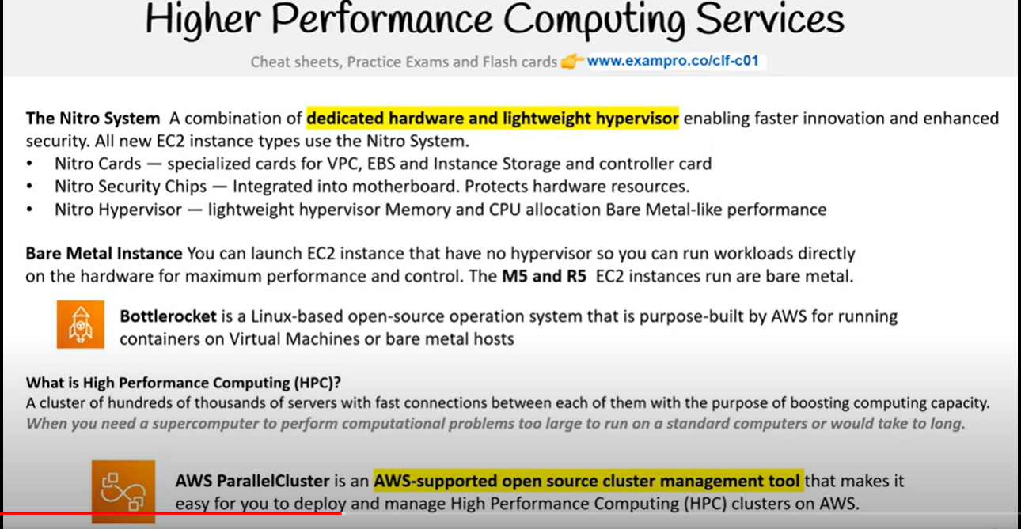

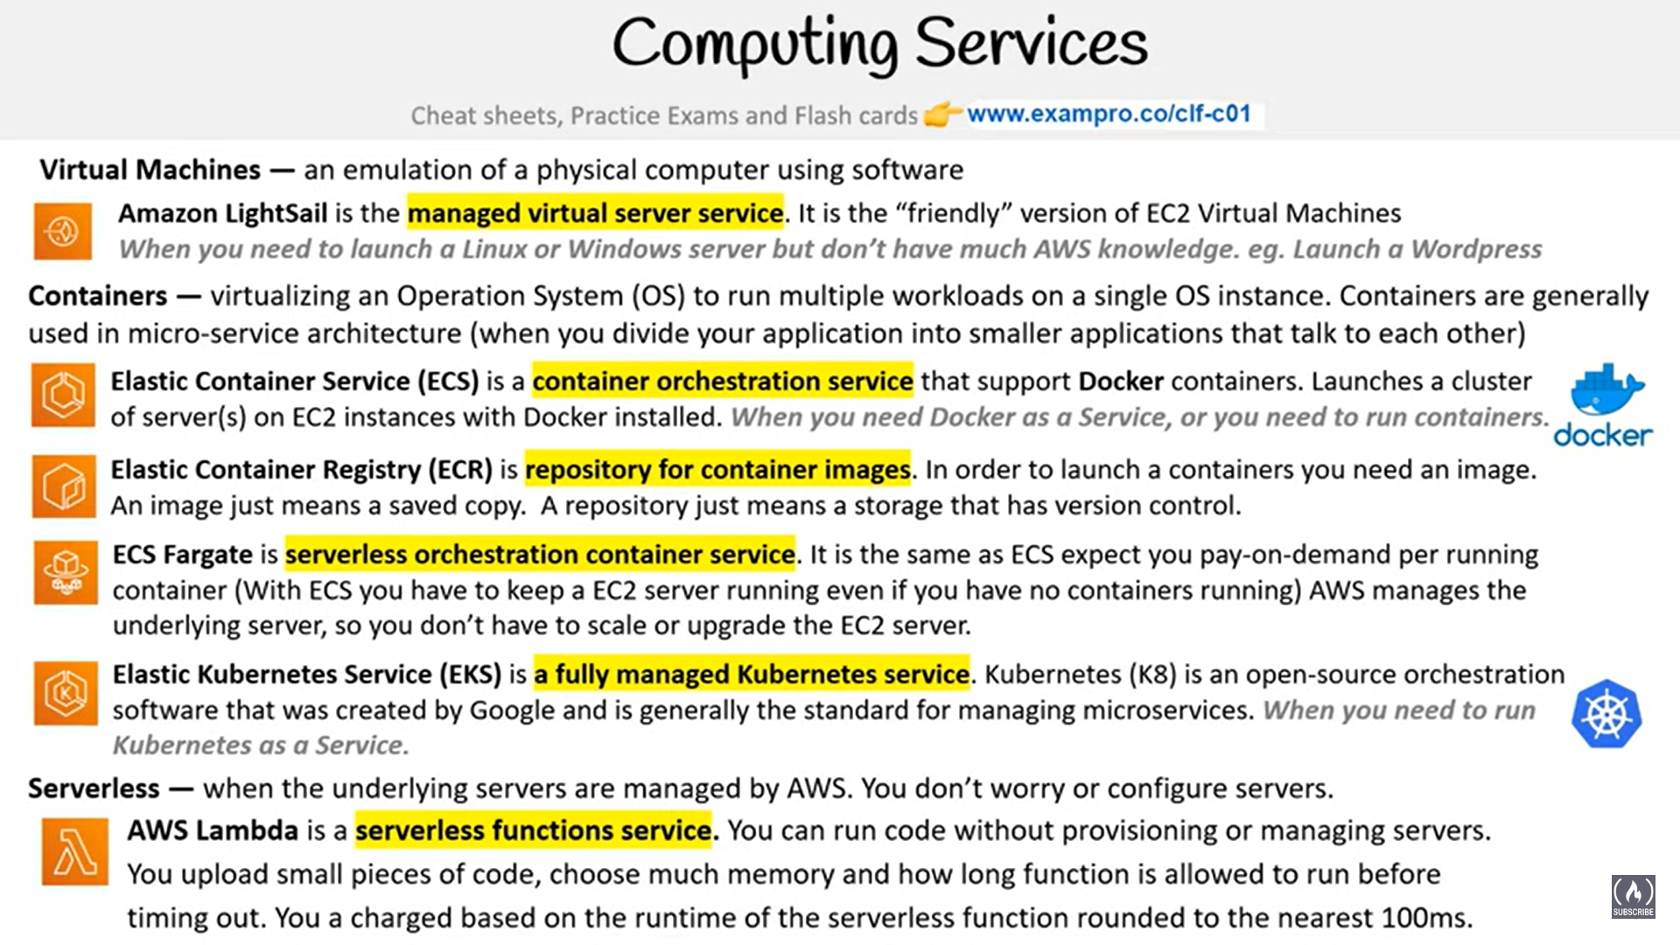

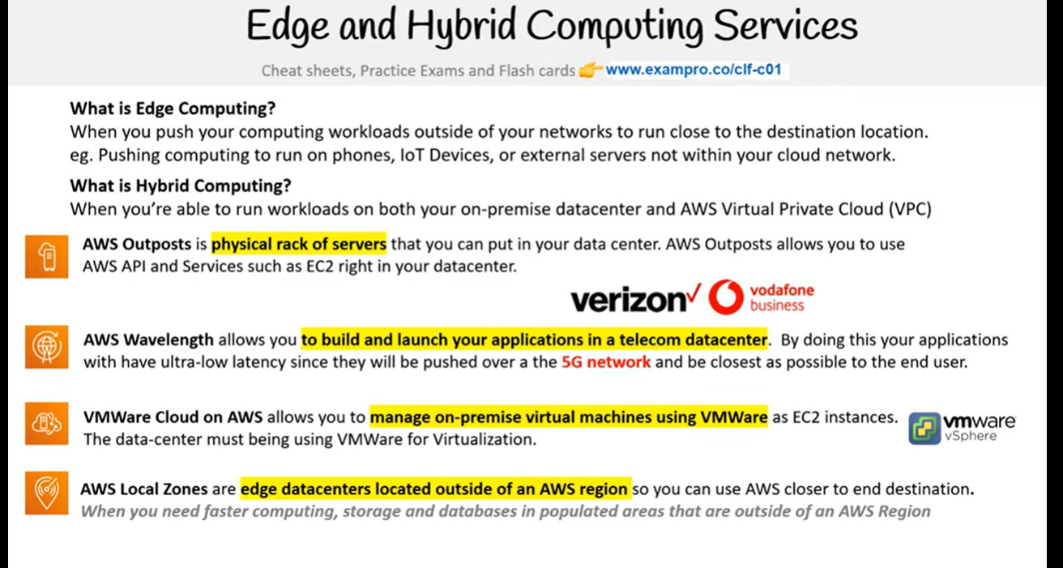

* EC2 is highly configurable server where we can choose AMI that affects options such as amount of cpu’s , memory , network bandwidth , operating systems

COMPUTE

EC2 Spot instances , reserved instanced and savings plan ways to save on computing by paying up in fully or partially by committing to a yearly contracts

* AWS Batch plans schedules and executes your batch workloads across the full range of AWS compute services and can utilize spot instances to save money
* AWS COMPUTE OPTIMIZER use machine learning to analyze previous usage and history to reduce cost and improve performance
* EC2 AUTOSCALING-GROUPS automatically adds or removes ec2 instances to meet the traffic demand and save money
* ELASTIC LOAD BALANCER distributes the traffic between the instances and re-routes the traffic from unhealthy to healthy instances
* AWS ELASTIC BEANSTALK (AWS EB) helps in easily deploying web-applications without developers having to worry about AWS services

AMAZON EBS –

* Block data is split into evenly split blocks directly accessed by the operating system supports only a single write volume

AMAZON ELASTIC FILE STORAGE (EFS)-

* files is stored with data and metadata
* Multiple connections via network share and supports multiple reads writing locks the file
* When we need a file share where multiple users or vm needs to access the same drive
* NFS and SMB protocols are used here

AMAZON SIMPLE STORAGE SERVICE (S3)

* https and api protocols are used in s3
* When we have to upload files without worry of the underlying infrastrucuture not intended for IOP

Q) What is Object Storage(object based storage)?

Ans :- Data storage architecture that manages data as objects as opposed to other storage architectures

* File systems which manages data as a files and fire hierarchy and
* Block storage which manages data as blocks within sectors and tracks

S3 STORAGE CLASSES

S3 Standard (default)

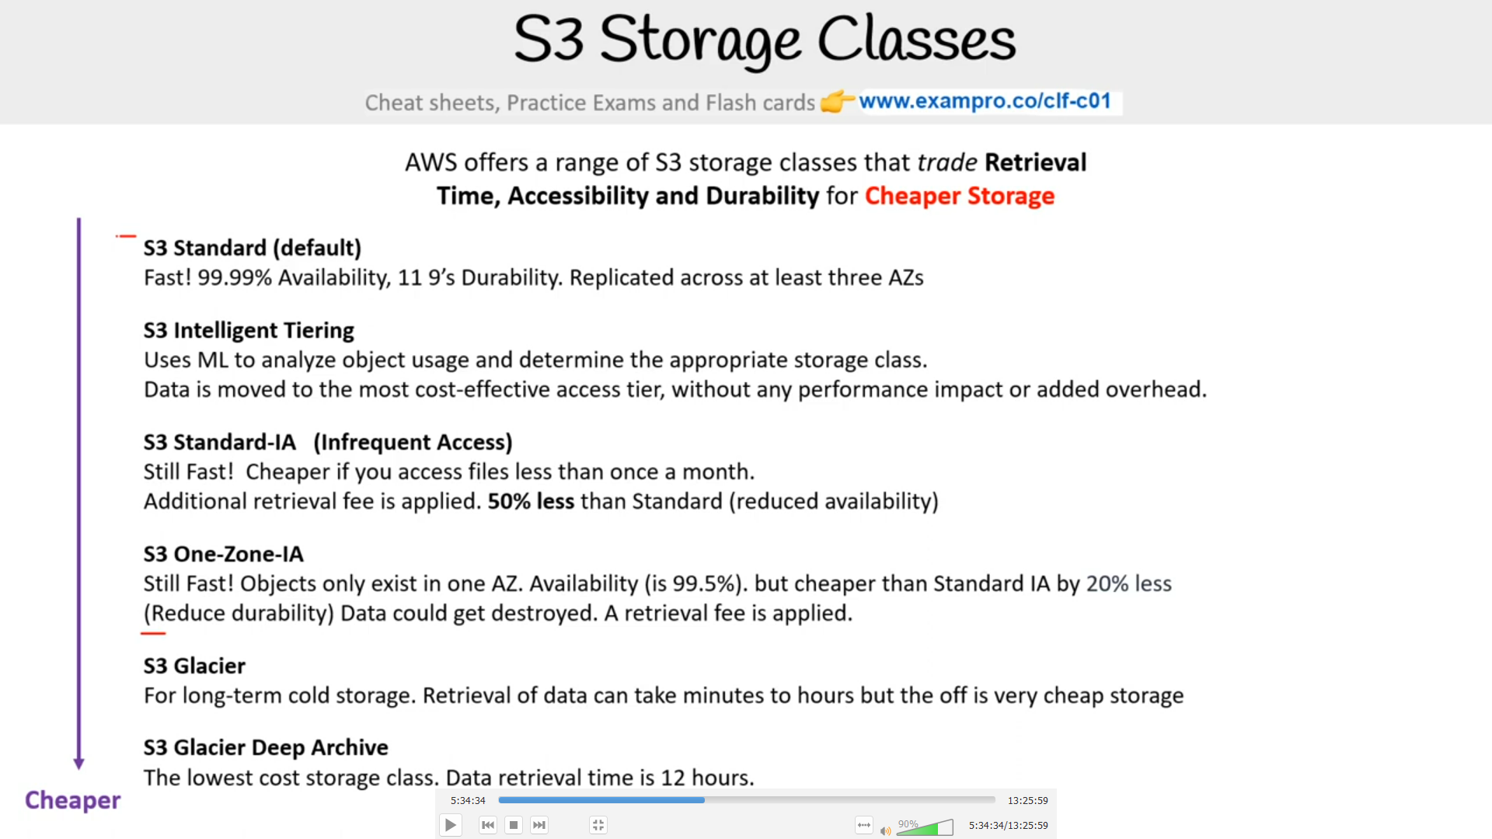

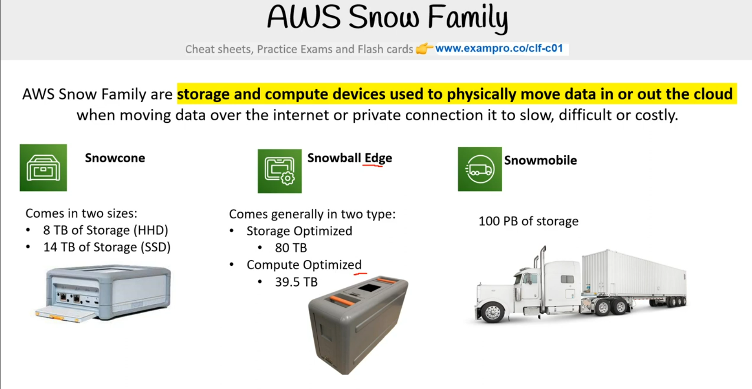

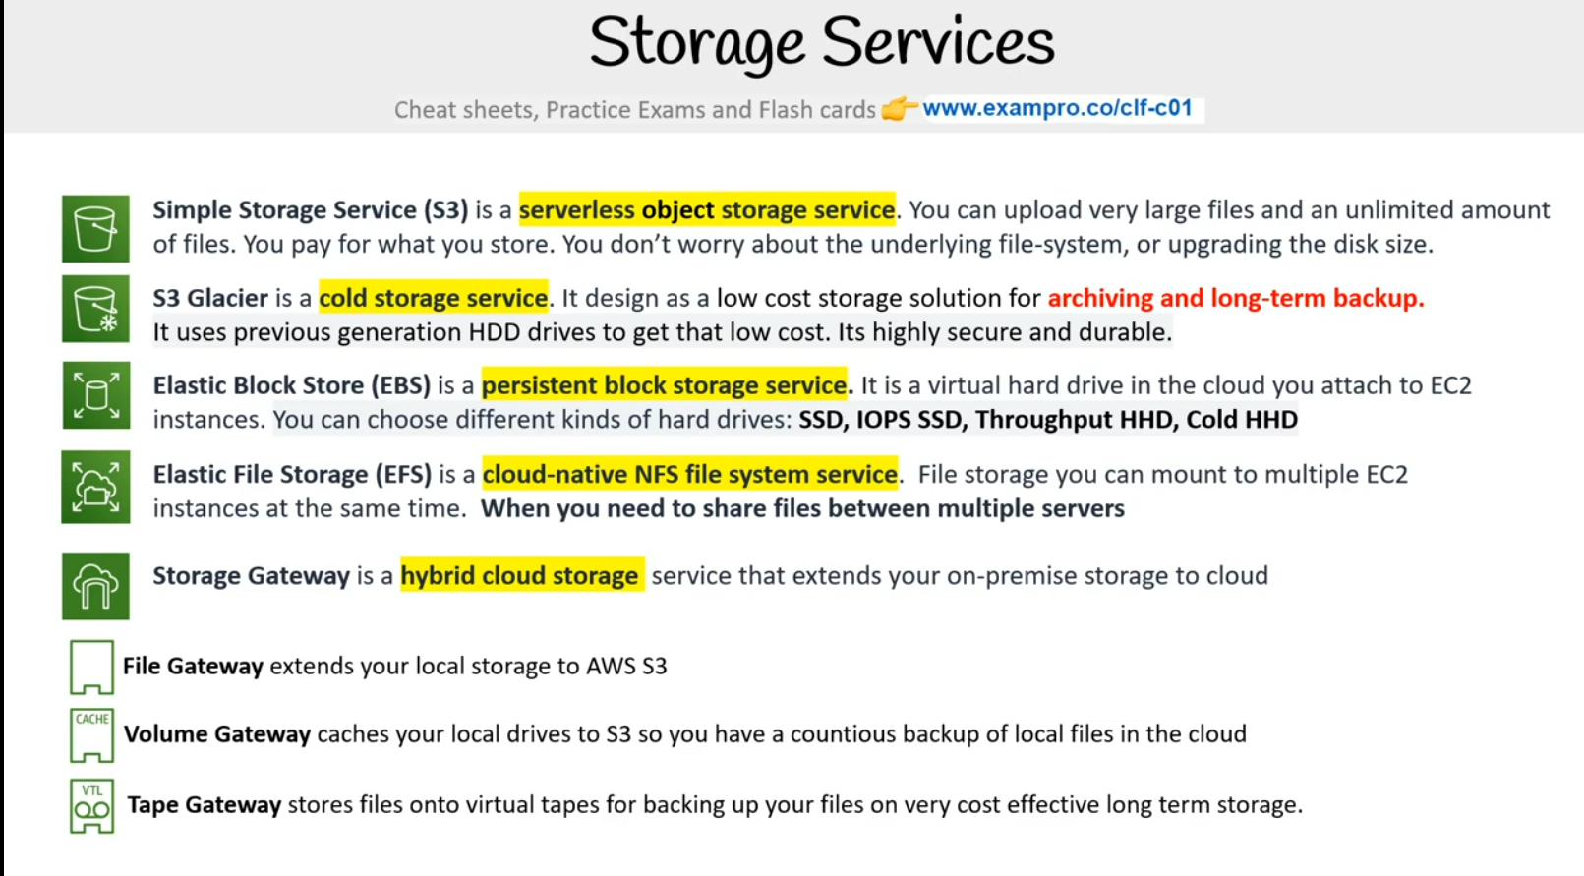

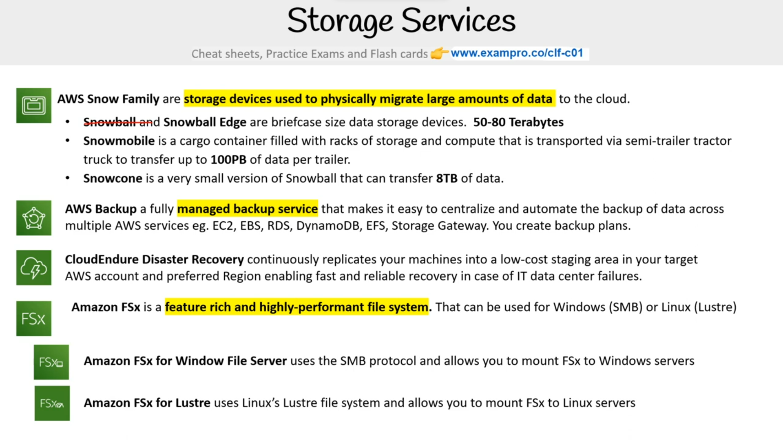

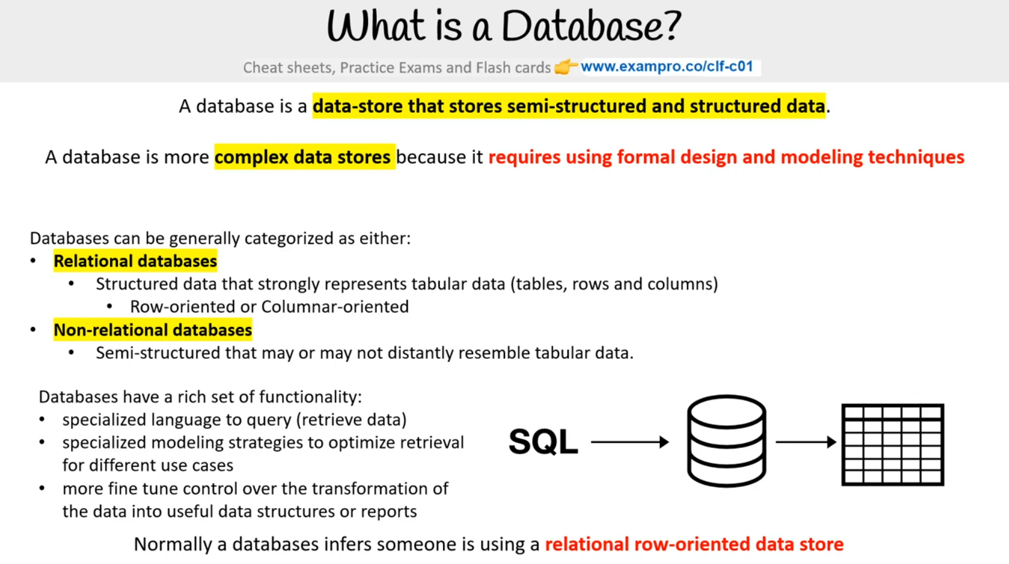

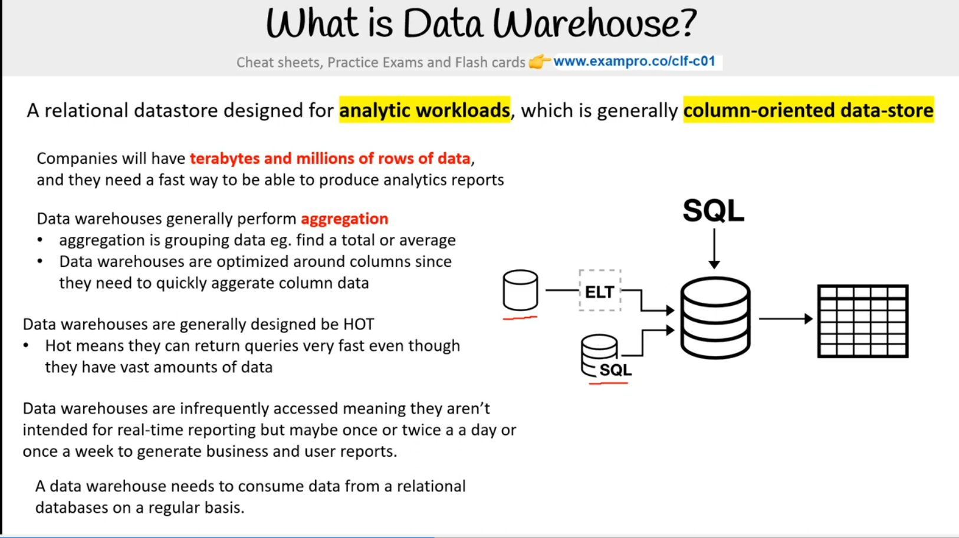

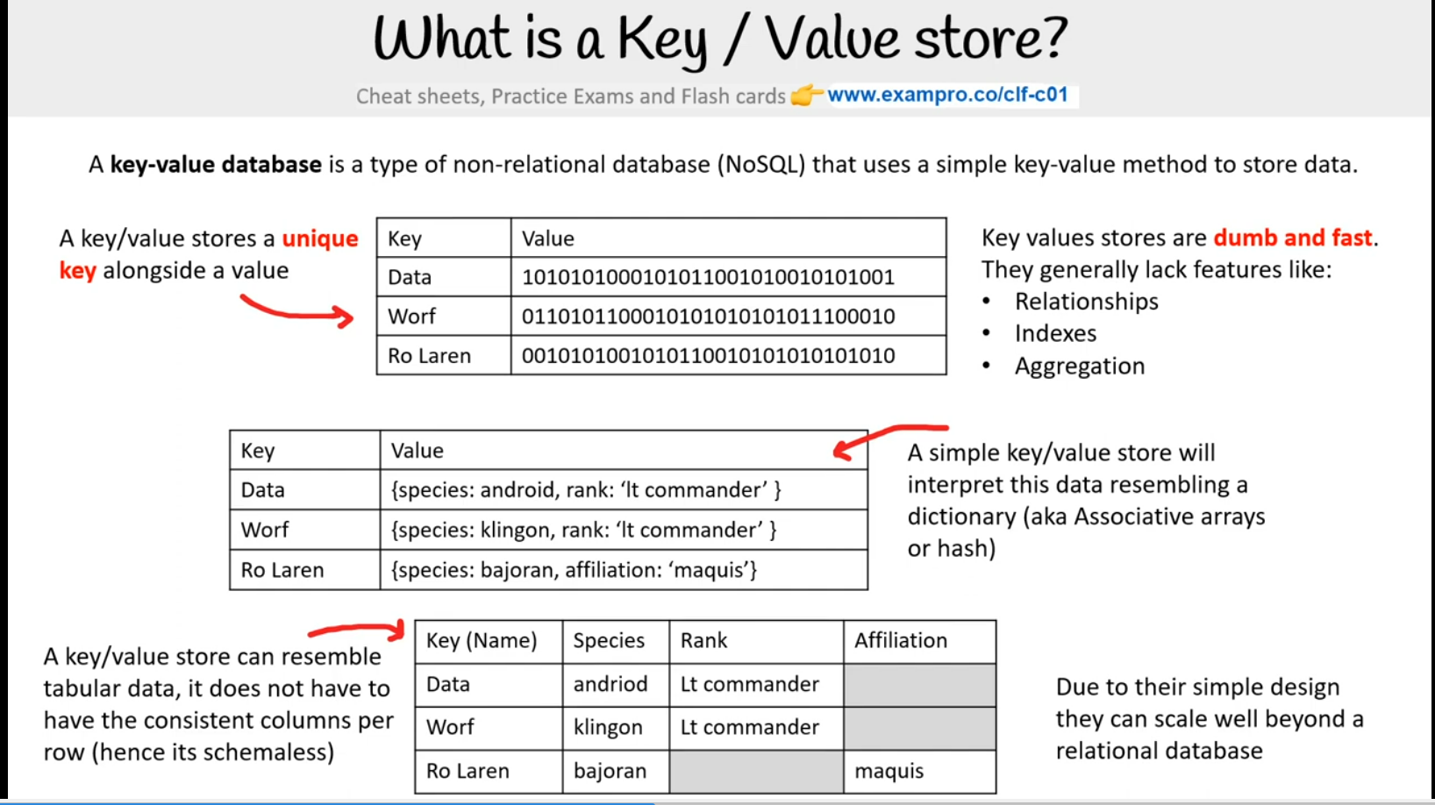

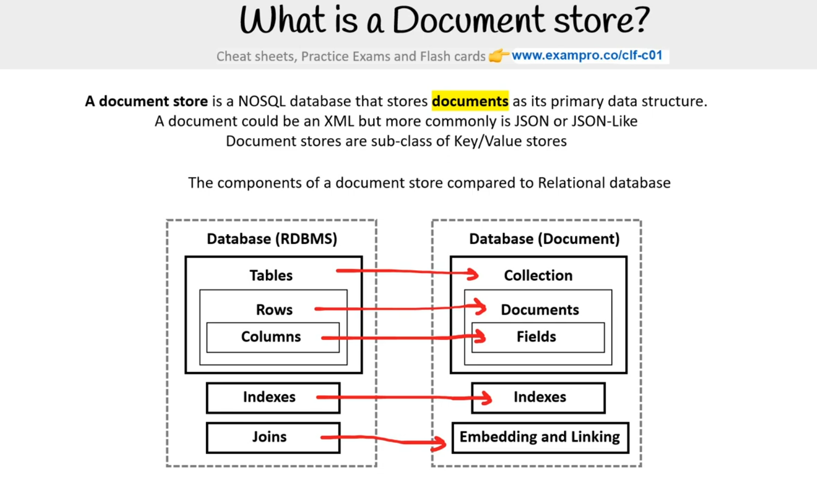

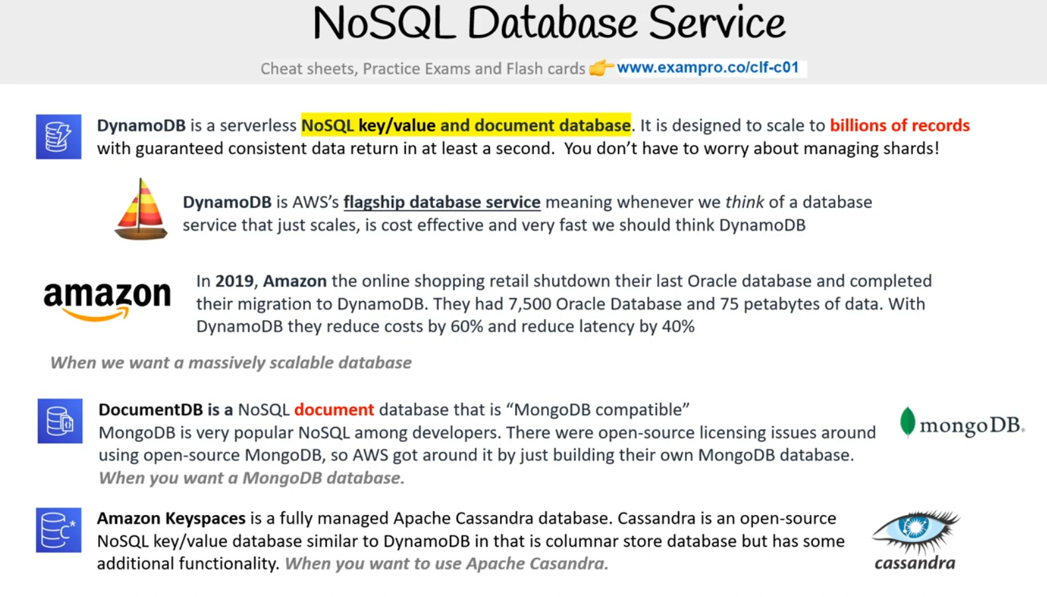

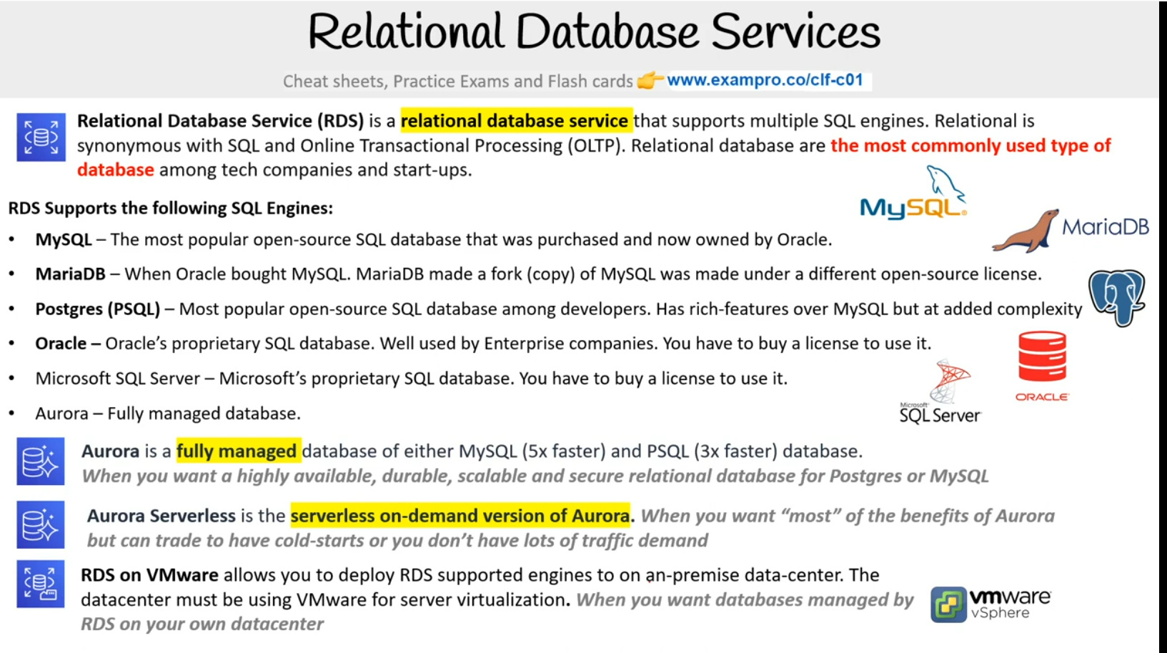

6.15.41

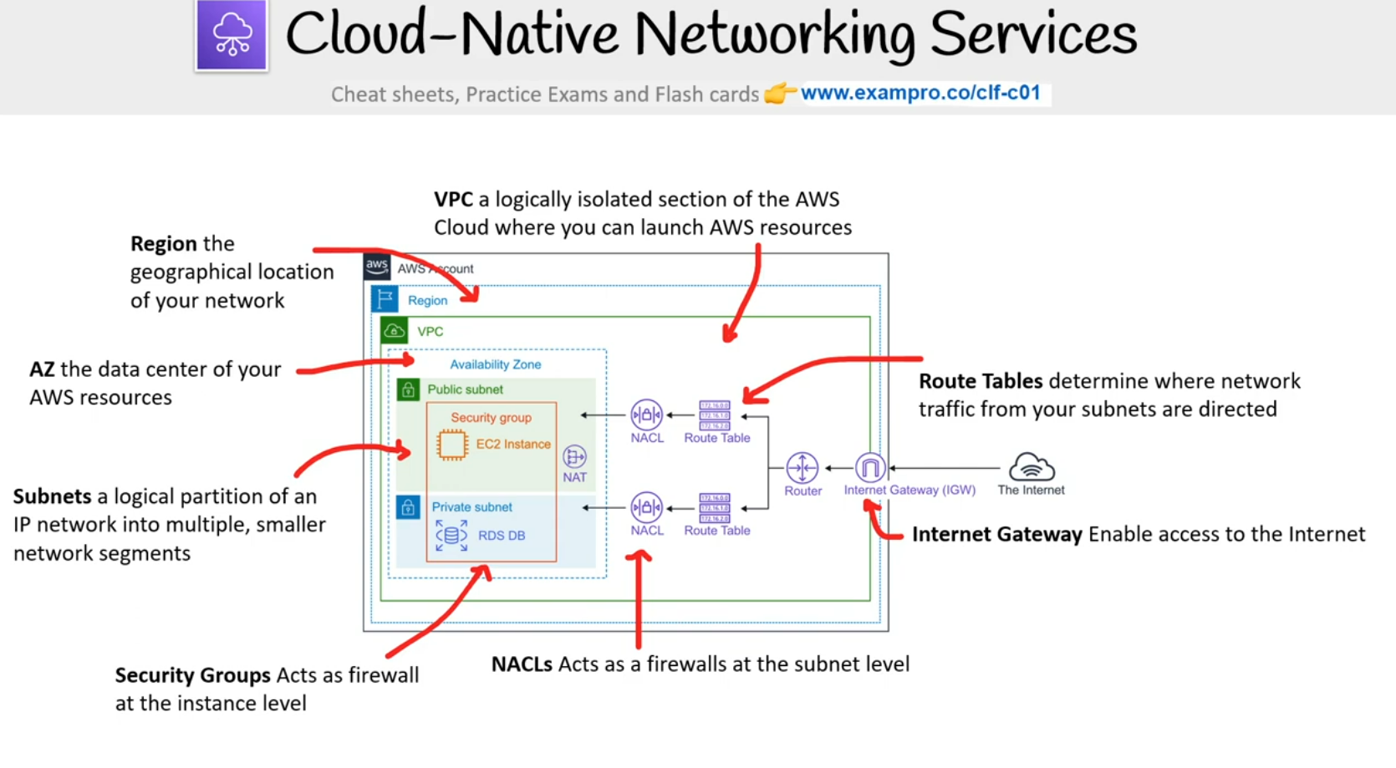

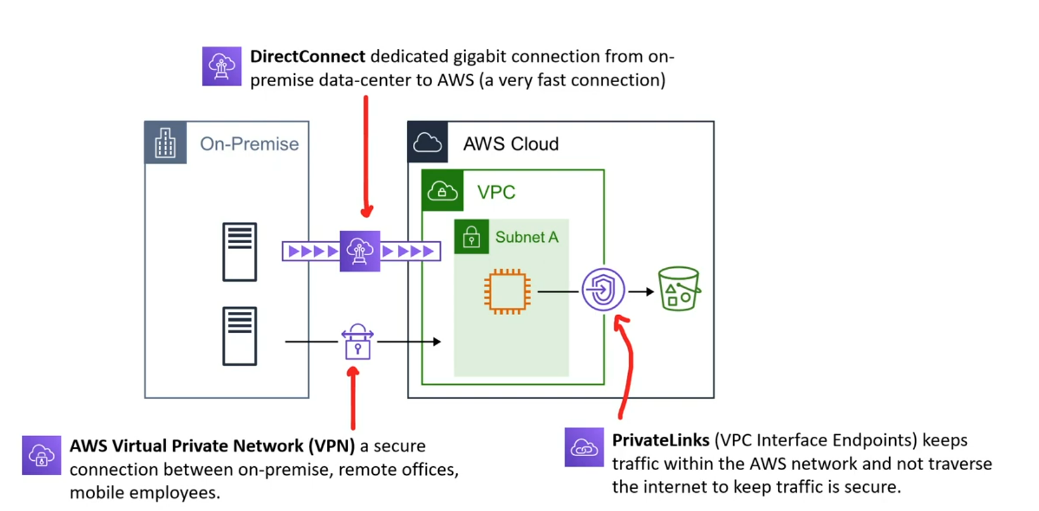

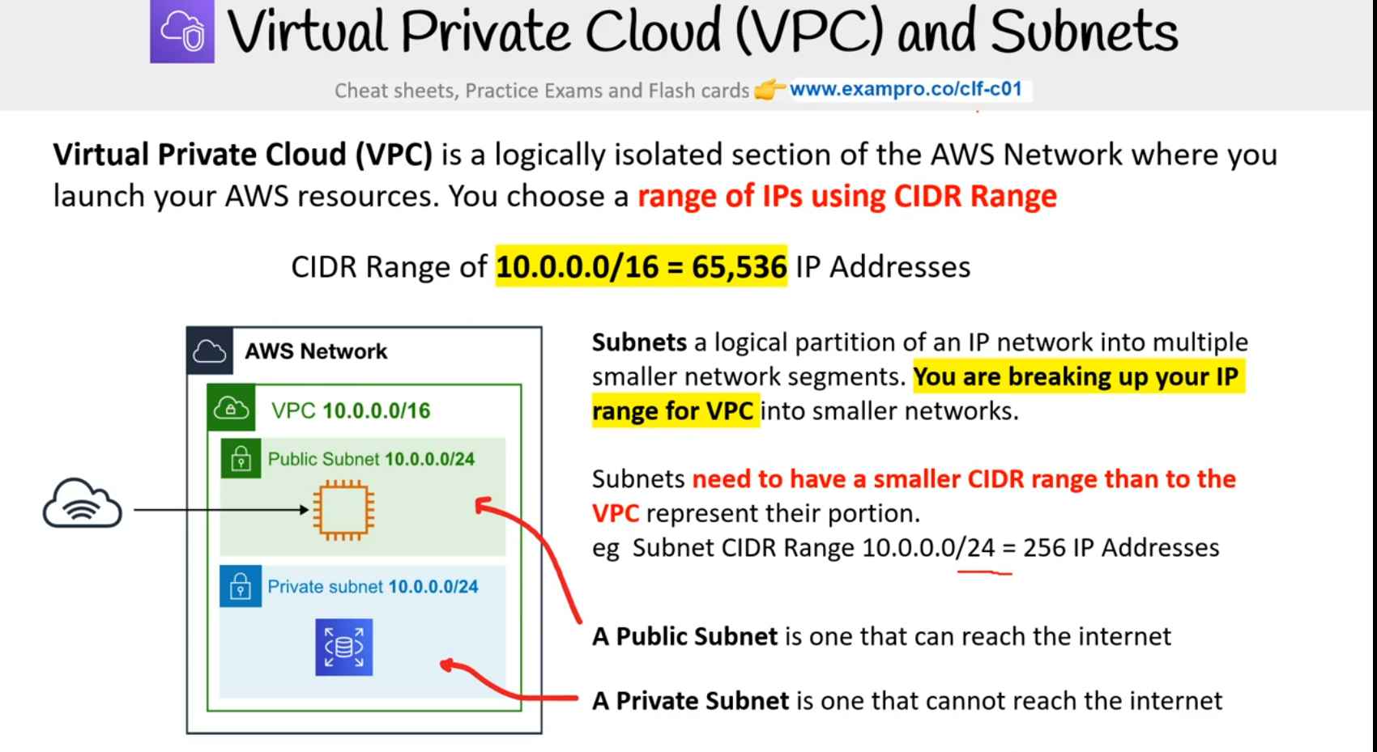

NETWORK ACCESS CONTROL LIST (NACL) :- It is like virtual firewall at the subnet level . Can block specific ip address for abuse or anything

SECURITY GROUPS (SG):-acts like a virtual fireawall at instance level denies all traffic. Can create only allow rules

Eg. Allow an ec2 instance to access on port 22 for ssh but cannot block single ip address

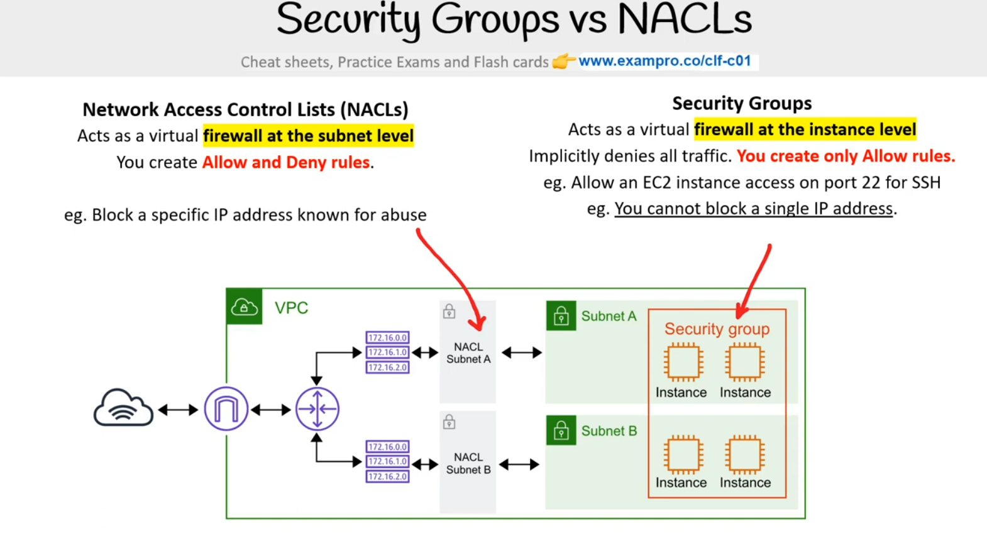

EC2 has 3 levels of tenancy

Dedicated Host

Dedicated Instance

Default 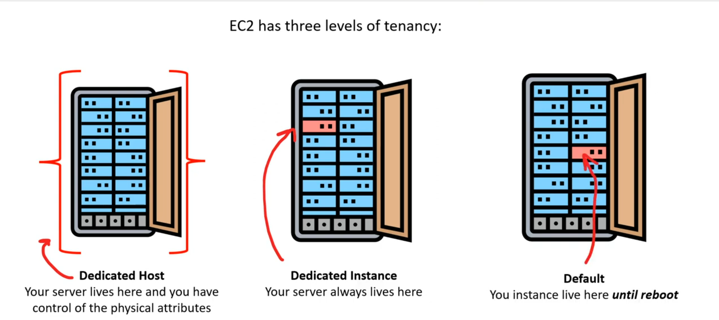

Elastic IP’s – Normally when we restart our ec2 instance aws provides a new public ip address so Amazon elastic ip gives an static address to our instances

AMAZON AUTOSCALING GROUP(ASG)

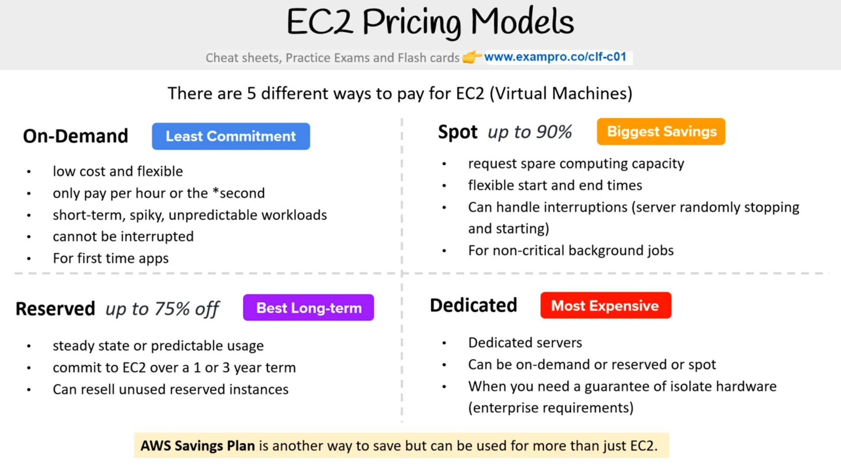

ON-DEMAND

* On-Demand is a pay-as-you-go model where you consume and then pay and charged by the second or the hour
* It is for applications where the workloads is for short-term , spikey or unpredictable . When you have a new app for development or you want to run experiment

RESERVED INSTANCES

* Designed for applications that have a steady predicatable usage or require reserved capacity
* Reduced pricing is based on ( Term \* Class Offering \* RI Attribute \* Payement Option)

EC2 Reserved Instance Marketplace allows to sell the unused Standard Reserved Instance (RI) to recoup your RI spend for RI you don’t intend or cannot use.

SPOT INSTANCES

* AWS has unused capacity that they want to maximize the utility of their idle servers
* Spot instance provide a discount of 90% compared to On-Demand pricing
* AWS Batch is an easy and convenient way to use spot pricing

DEDICATED INSTANCES

* Designed to meet regulatory requirements
* 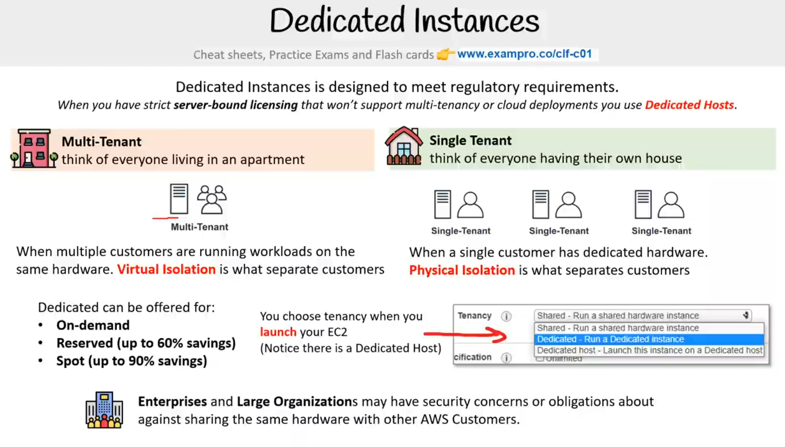

AWS SAVINGS PLAN

Savings plans offer similar discount as Reserved Instances but simplifies the purchasing processs

There are three type of savings plan

1. Compute Savings Plans
2. EC2 Instance Savings Plans
3. SageMaker Savings plan

* Compute Savings plans provides the most flexibility and to help to reduce your cost by up to 66%.These plans automatically apply to EC2 instance usage , AWS Fargate and AWS Lambda service regardless of instance family, size , AZ , region ,OS and tenancy
* EC2 instances provides the lowest price offering savings plan up to 72% in exchange for commitment to usage of individual instances families in a region
* SageMaker helps us reduce sagemaker cost by upto 64% automatically apply to sagemaker usage regardless of instance family size component or aws region

ZERO-TRUST MODEL

The Zero Trust model operates on the principal of “trust no one , verify everything”

In zero Trust model identity becomes the primary security perimeter

Ques ) What is the Primary Security Perimeter?

Ans :- The primary or new security perimeter defines the first line of defense and its security controls that protect a company’s cloud resources and assest

* Network-Centric (old way) :- Traditional security focused on firewalls and vpns since there were few employees or workstation outside the office or they were in specific remote offices
* Identity-Centric (New way) :- BYOD , remote workstation is much more common . we cannot trust that the employees is in secure location we have identity based security controls like MFA or providing provisional access based on the level of risk from where , when and what a user wants to access . eg IAM

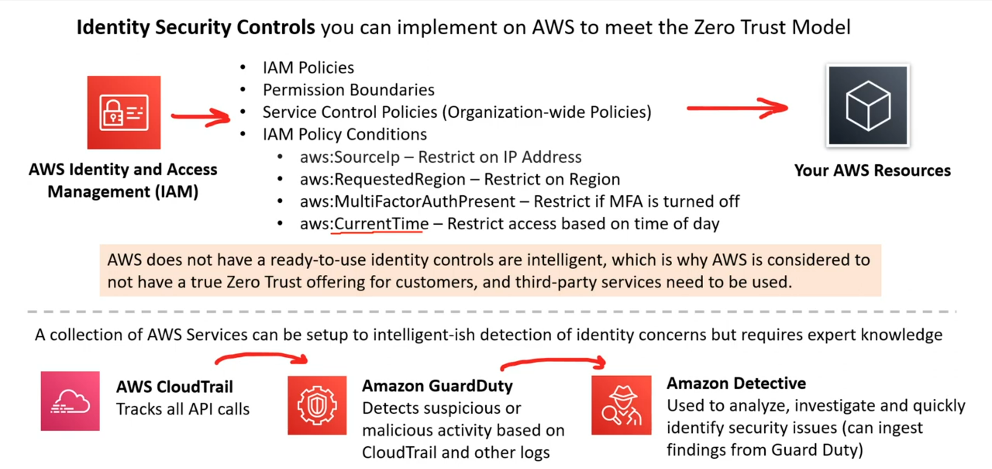

AWS IDENTITY AND ACCESS MANAGEMENT

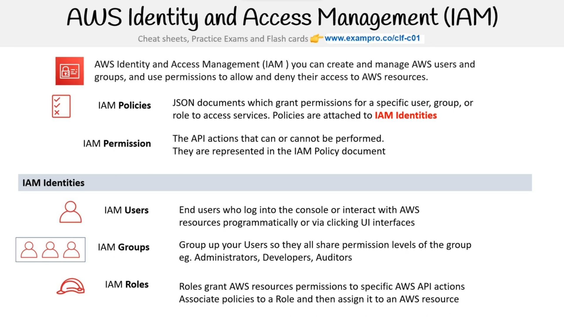

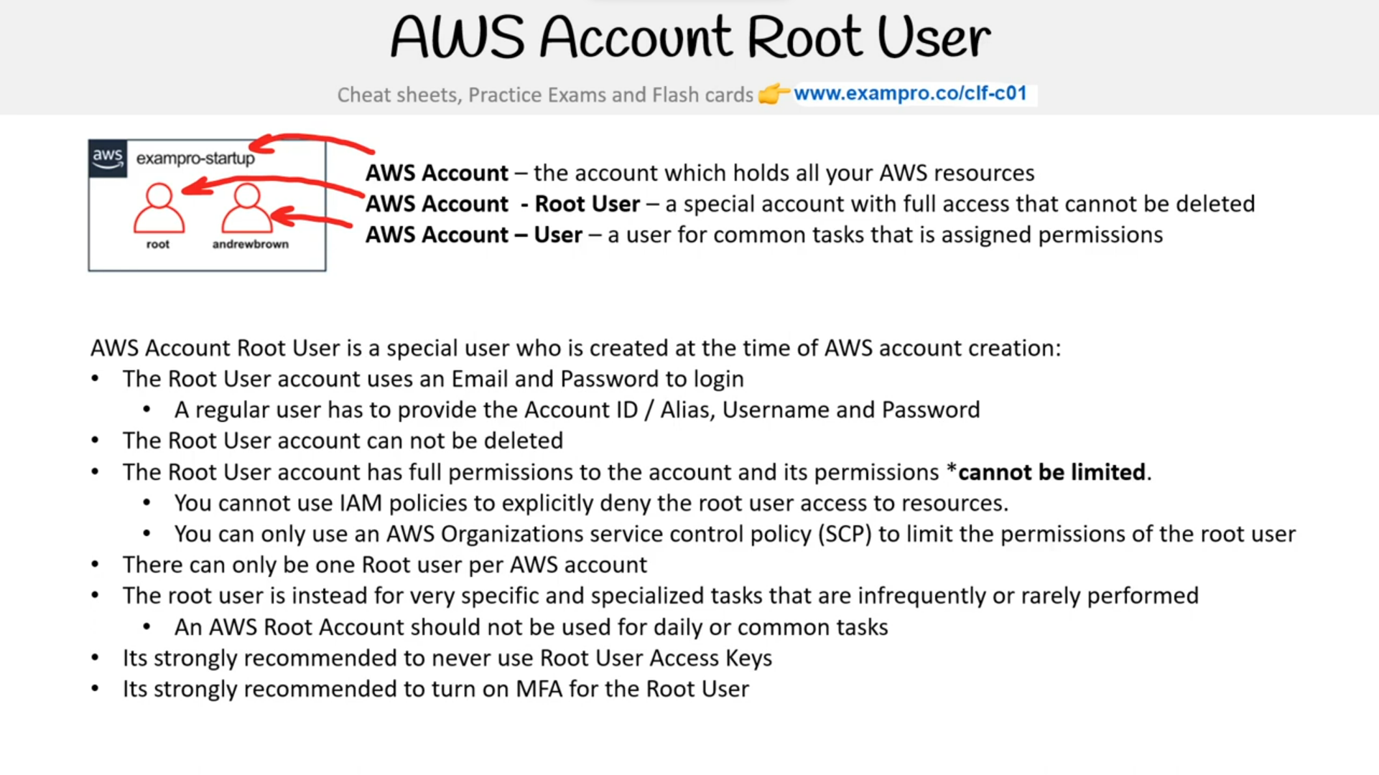

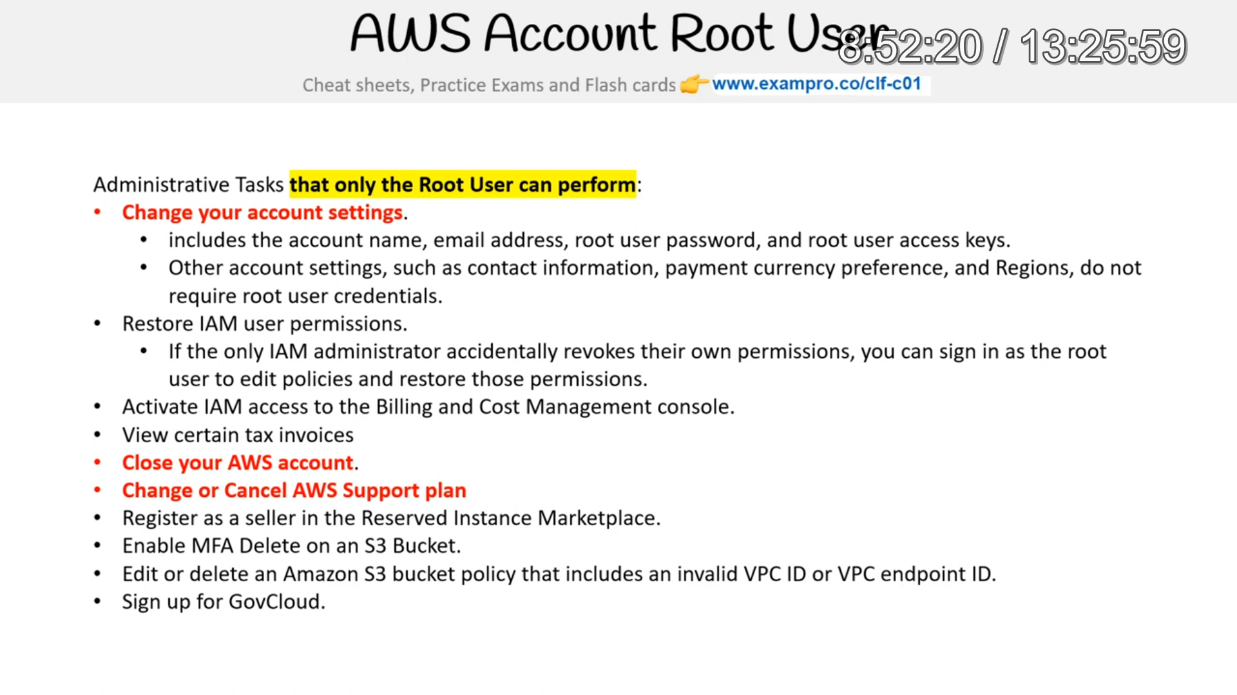

AWS SINGLE-SIGN ON

AWS Single Sign ON (SSO) is where you create or connect your workforce identities in AWS once and manage access centerally across your AWS organization

Application Integration is the process of letting two independent applications to communincate and work with each other commonly facilated by an intermediate system

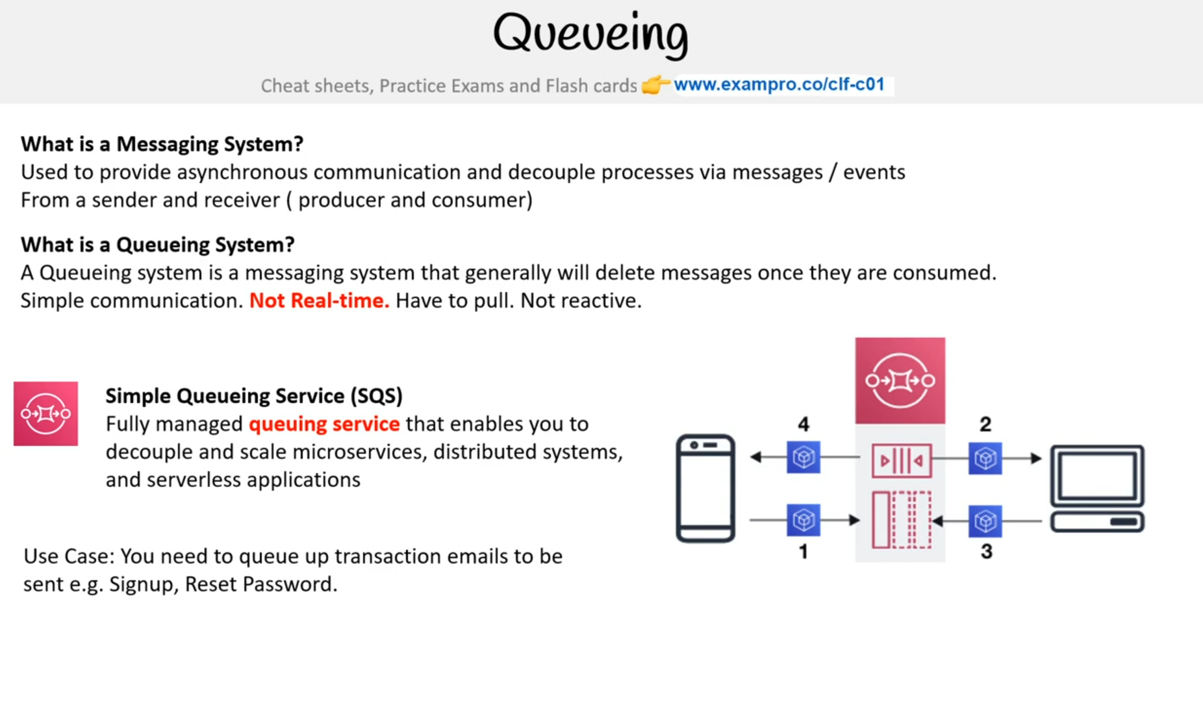

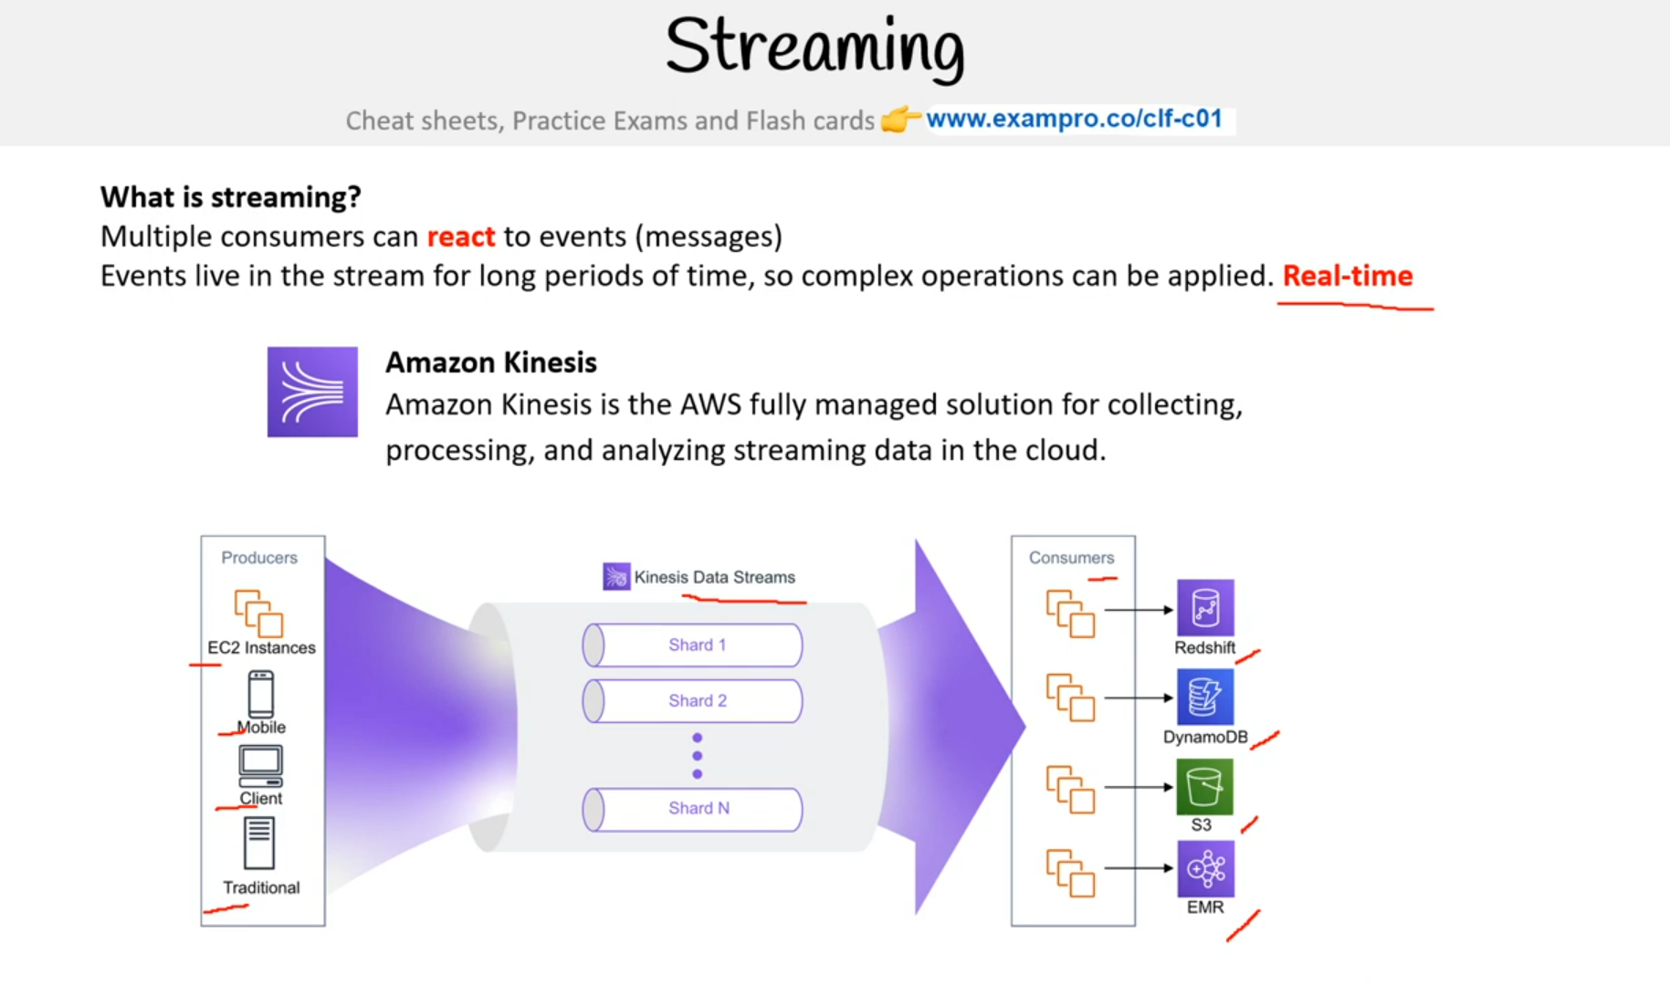

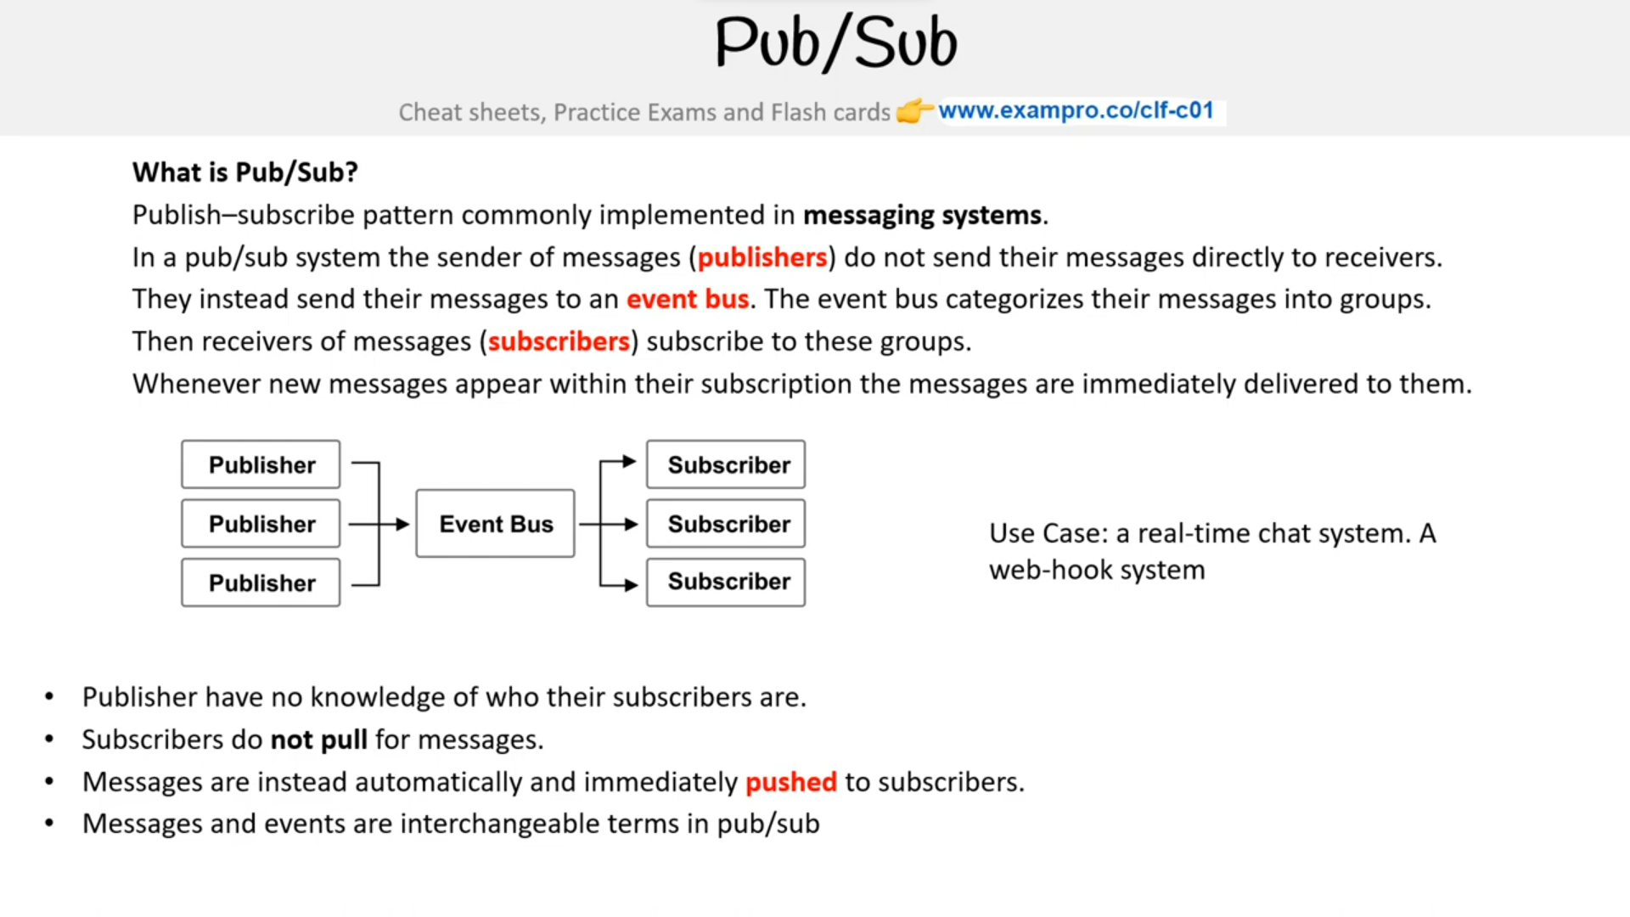

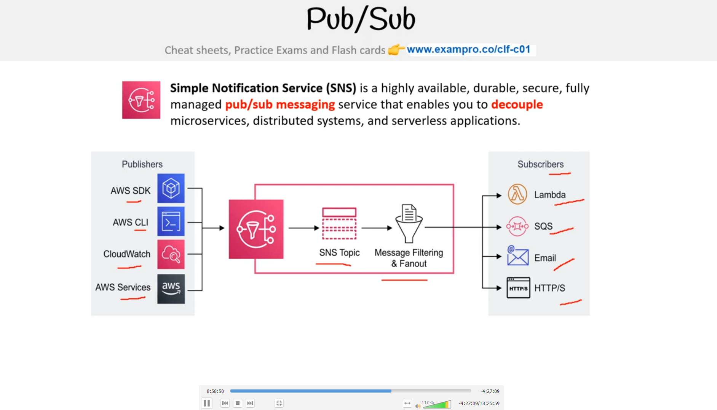

API GATEWAYS

An API Gateway is a program that sits between a single entry point and multiple backends . API Gateway allows for throttling logging routing logic or formatting of request and response.

* Amazon API Gateway is a solution for create secure API in your cloud environment at any scale .Create API that acts as a front door for applications to access data,business data , logic or functionality from backend services
* 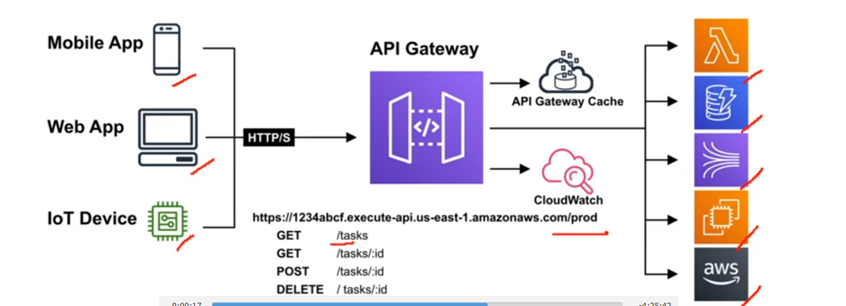

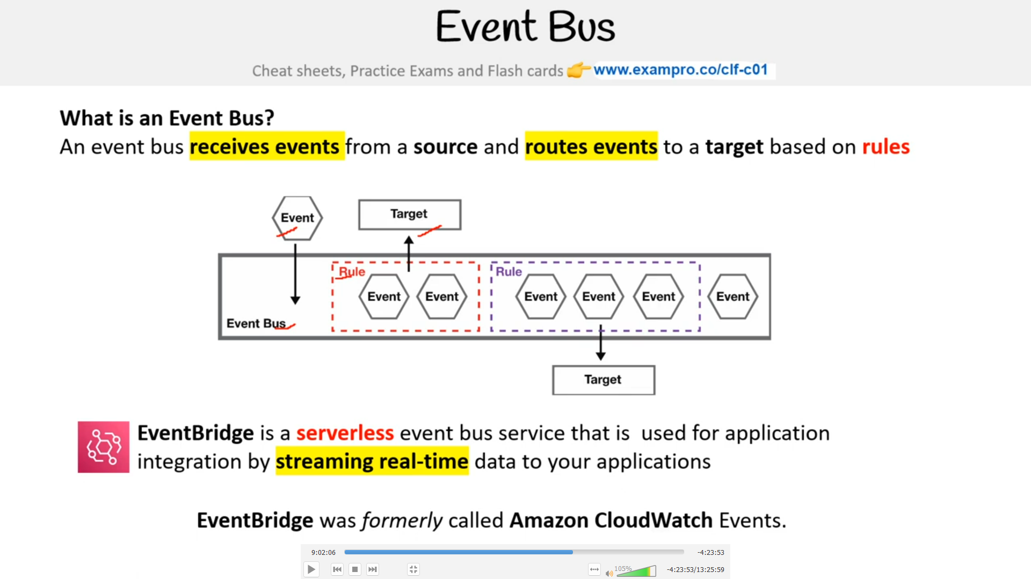

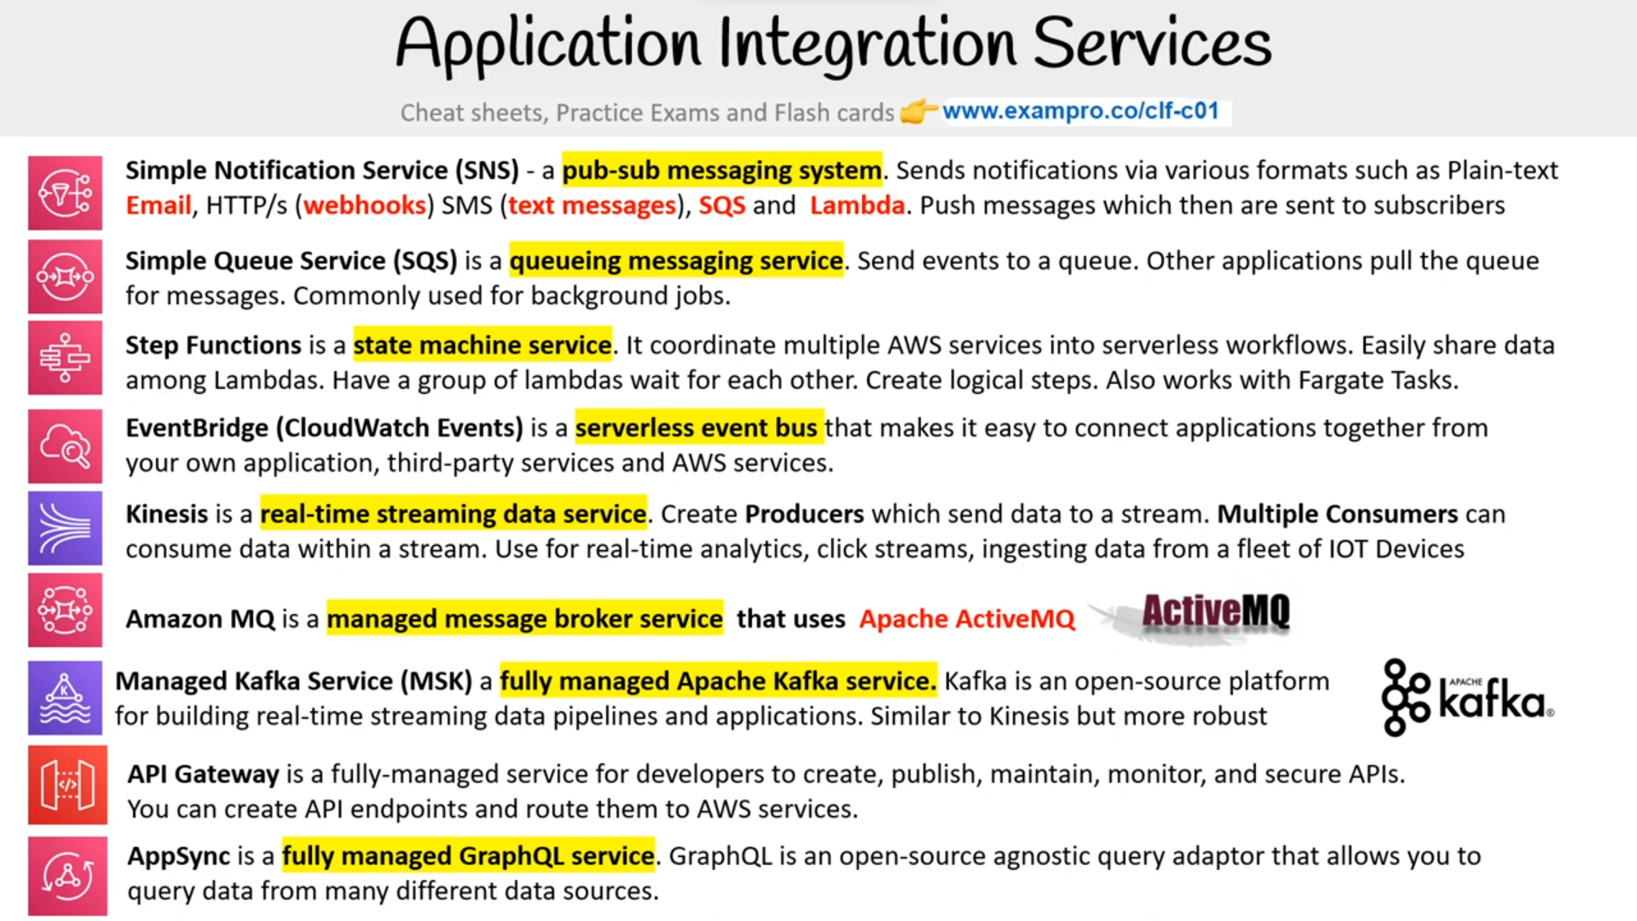

* Simple Notification Service(SNS) :- a pub-sub messaging system. Send notificaitions via various formats as plain text , email , http/s , sms .Push message which then are sent to subscribers
* Simple Queue Service (SQS) :- A queuing message service . send events to ques.other applications pull the queue for message used for background jobs

VMS vs Containers

VMs don’t make best use of use of space and runs on hypervisor and may cause config conflicts, security problems or resource hogging

Containers allows us to run multiple apps on Docker deamon instead of hypervisor and all apps are isolated from each other .One more benefit is it allows us to launch new containers and configure OS dependencies per container

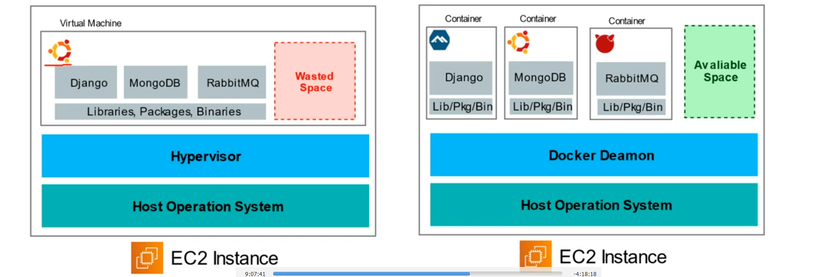

Microservices

There are two types of Architecture commonly known as

1. Monolithic Architecture where we use one app which is responsible for everything like services Marketing frontend backend
2. Microservices Architecture is on the other side where we use multiple apps that are responsible for one thing and functionality are isolate and stateless
3. 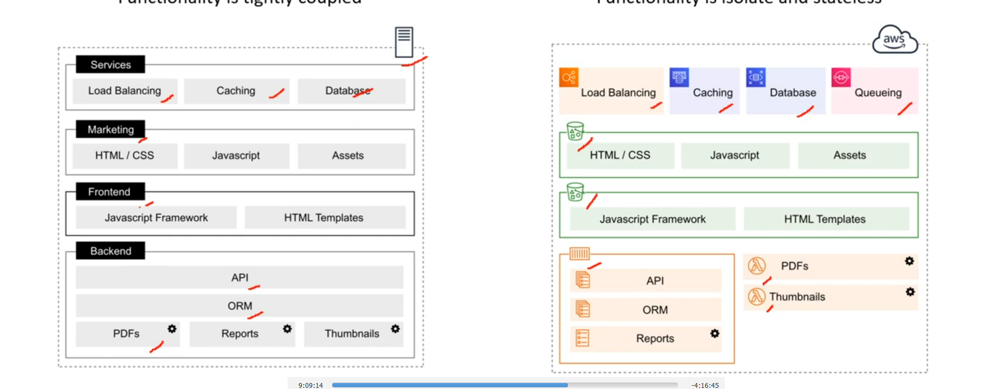
4. Kubernetes is an open-source container orchestration system for automating deployment , scaling and management of containers

* Commonly known as K8
* Advantage of k8 over Docker is ability to run containers distributed across the multiple vm
* A unique component of Kubernetes are pods which is group of multiple containers with shared storage , networking resources
* It is ideally for micro-services architectures where a company has ten to hundreds of services they need to manage

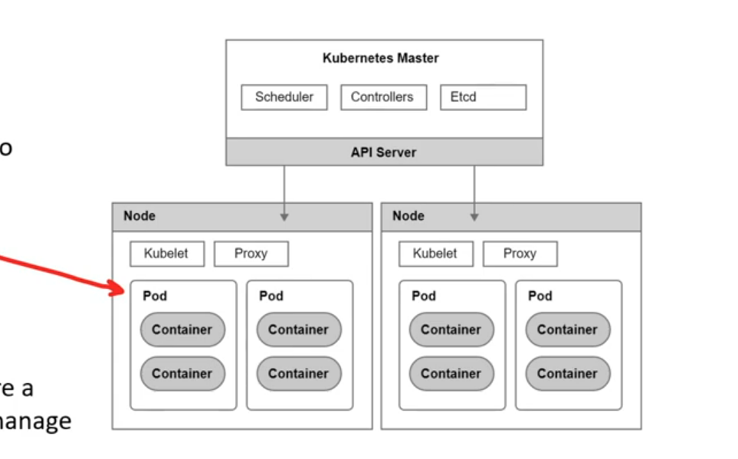

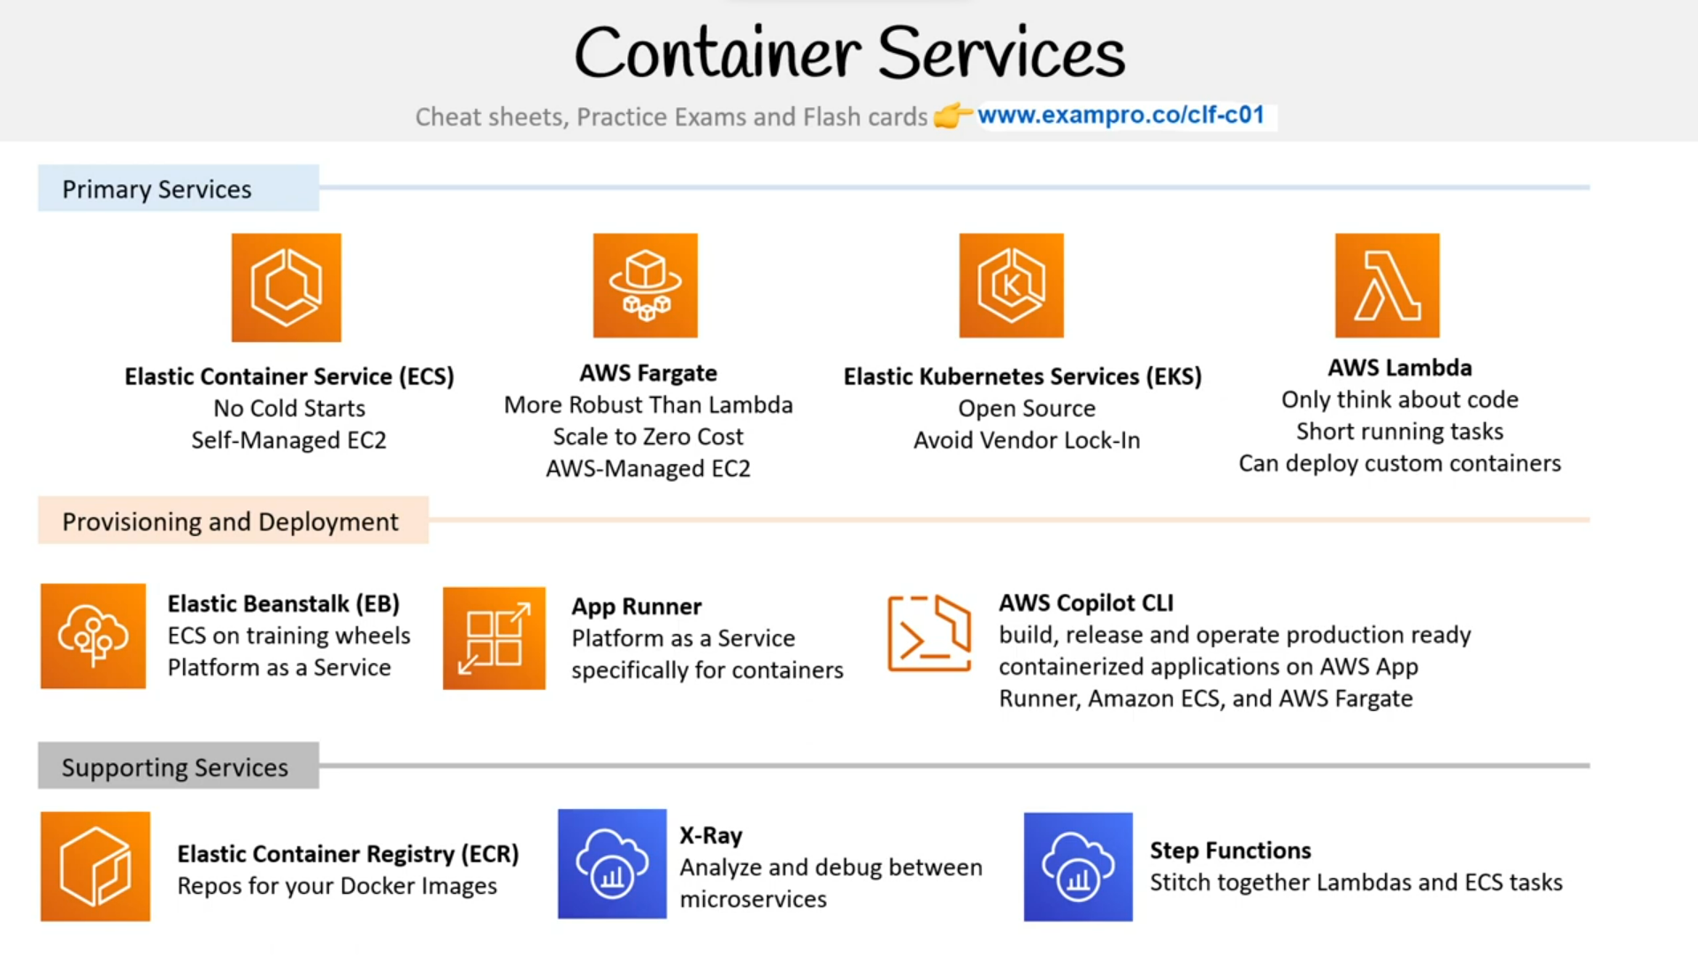

ORGANIZATION AND ACCOUNTS

* AWS Organizations :- Aws organisations allows the creation of new AWS accounts .Centerally manage billing control access compliance security and share resource across your Aws account
* Root Account User is a single sign-in identity that has complete access to all Aws services and resources in an account . Each account has a Root Account User.
* Organizational Units are a group of Aws accounts within an organization which can also contain other organizational units creating a hierarchy
* Service Control Policy giving central control over the allowed permissions for all accounts in your organization, helping to ensure your accounts stay within your organization guidelines

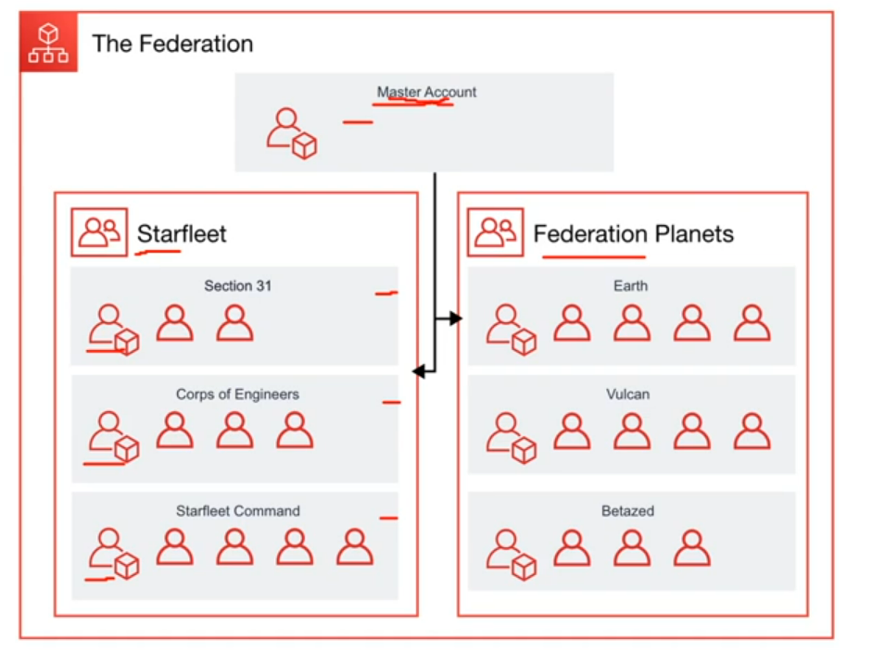

* AWS Control Tower helps towers Enterprise quickly set-up a secure AWS muli-account provides you with a baseline environment to get started with multi-account architecture
* Aws is a replacement for retried AWS Landing Zones

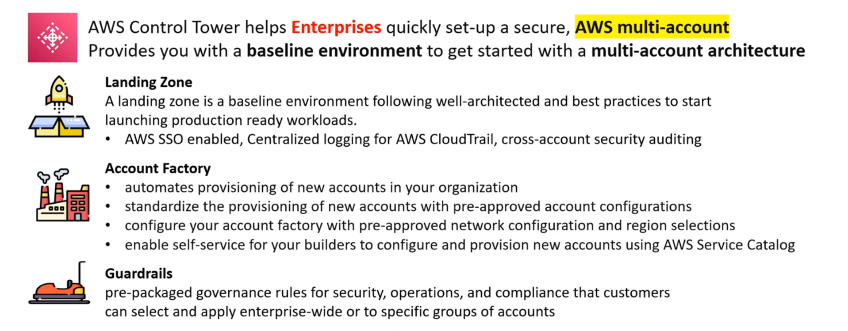

AWS CONFIG

Aws Config is a Compliance-as-code that allows us to manage change in your AWS accounts on a per region basis

#*Compliance-as-code means when we utilize programming to automate the monitoring , enforcing and remediate changes to stay compliant with expected configurations*

*#Change Management in cloud infrastructure is when we have a formal process to monitor changes enforce changes Remidate changes*

AWS Quick starts are prebuilt templates by Aws and aws partners to help deploying wide range of stacks

Provisioning Services

The allocation or creation of resources and services to a customer. Aws Provisioning Services are responsible for setting up and then managing those aws services

1. Elastic Beanstalk (EB)
2. Aws OpsWorks
3. CloudFomation
4. AWS Quickstarts
5. AWS marketplaces
6. Aws App Runner
7. Aws copilot
8. Aws codestar
9. Aws cloud Development kit(CDK)

* Amazon lightsail :- managed virtual server service
* Elastic Container Servicer(ECS):- container orchestration service
* Elastic Container Registry (ECR):- repository for container images
* ECS Fargate :- serverless orchestration container service
* Elastic Kubernetes Services (EKS):- fully managed Kubernetes service

SERVERLESS

AWS Lambda :- serveless function service

AMAZON S3 BUCKET

1. S3 STANDARD (DEFAULT)
2. S3 INTELLEGENT TIERING :- use ml to analyze object usage and to determine the appropriate storage class
3. S3 Standard IA :- Fast and cheap if access files less than once a month
4. S3 one zone IA :- Still fast and the objects exist in one AZ. Availablity zone is 99.5 and cheaper than Standard IA by 20%
5. S3 Glacier :- For long term cold storage.Retrival of data can take upto minutes to hour
6. S3 Glacier Deep Archieve :- The lowest cost storage class. Data retrieval time is 12 hours

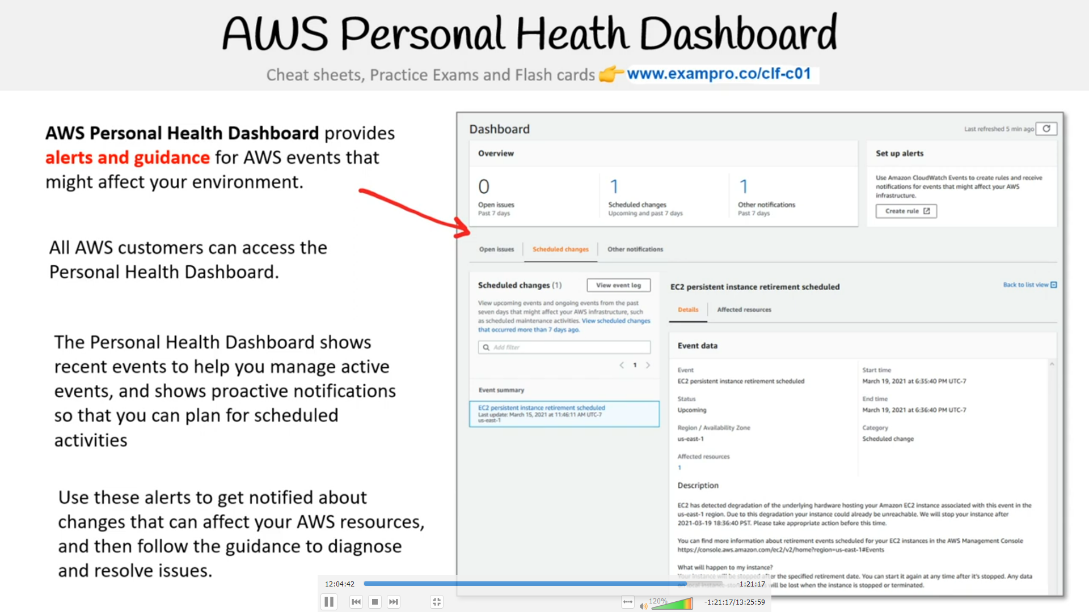

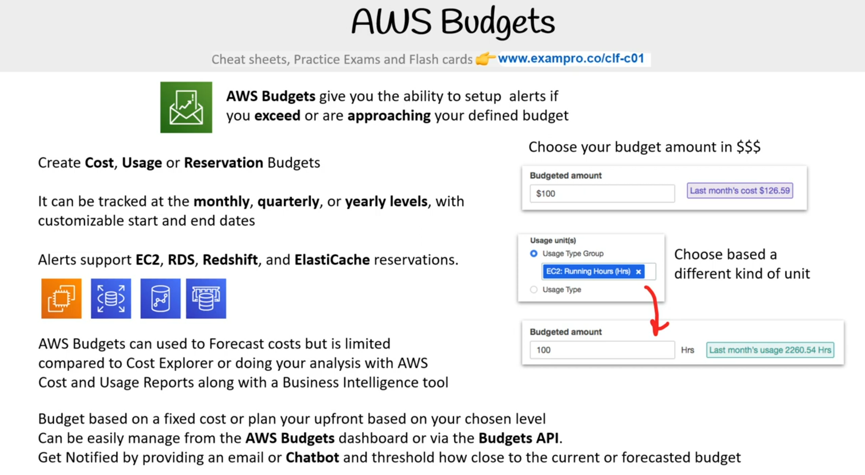

AWS Budget Report is used alongside AWS Budgets to create and send daily , weekly or monthly reports to monitor the performance of Aws Budget that will be emaled to specific emails